1. Python program to find digital root of a number

Description:

A digital root is the recursive sum of all the digits in a number. Given n, take the sum of the digits of n. If that value has more than one digit, continue reducing in this way until a single-digit number is produced. This is only applicable to the natural numbers.

digit_root(0)= 0

digital_root(16)

=> 1 + 6

=> 7

digital_root(132189)

=> 1 + 3 + 2 + 1 + 8 + 9

=> 24 ...

=> 2 + 4

=> 6

def DigitalRoot(number): addper = 0

while number >=10:

number = sum(int(digit)for digit in str(number)) addper +=1

#I highly recommend using return instead of print, but for testing purposes I used print

print(number) DigitalRoot(132189)

**Output:**

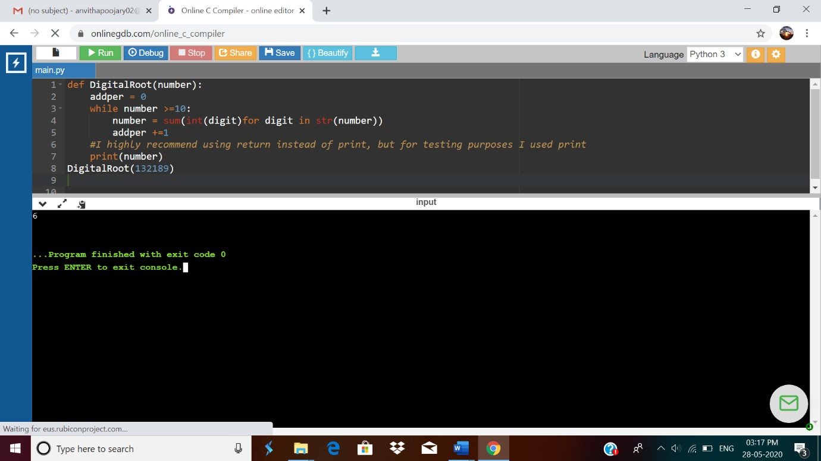

1. JAVA PROGRM-BALANCED BRAKET

Write a function that accepts a string consisting entiring of brackets ({}) and returns whether it is balanced. Every "opening" bracket must be followed by a closing bracket of the same type. There can also be nested brackets, which adhere to the same rule. f('()[]{}(([])){[()][]}') // true

f('())[]{}') // false

import java.util.Stack; public class Main {

public static void main(String[] args) {

System.out.println(is_parentheses_balanced("()[]{}(([])){[()][]}"));

}

public static boolean matchingPeer(char open , char close){ if ( open == '(' && close == ')'){

return true;

}

if ( open == '[' && close == ']'){ return true;

}

else{

return false;

}

}

public static boolean is_parentheses_balanced(String equation){

char[] c = equation.toCharArray();

Stack <Character> myStack= new Stack <Character> (); for (int i = 0; i < c.length; i++){

if(c[i]=='(' || c[i] == '[' ){ myStack.push(c[i]);

}

else if (c[i]== ')' || c[i]==']'){

if(matchingPeer(myStack.peek(),c[i]) == true){ myStack.pop();

} else {

return false;

}

}

}

if(myStack.isEmpty()){ return true;

}

else {

}

}

}

# Output:

return false;

